School for Advanced Research
Facility Rental Information
January 2019

Contact for rental fees and scheduling: Liv Turner, Executive Assistant to the President
505.954-7211 or turner@sarsf.org

Special Considerations
- Rental Hours: Weekdays (Mon-Fri) 9:00-5:00pm & Evenings 5:00-8:00pm
Weekends (Sat-Sun) 9:00-5:00pm subject to staff availability
- Not-for-profit organizations and Business Sponsors ($2,500+) receive 10% discount on meeting rooms
- 3% transaction fee charged for all credit card payments
- SAR parking assistance staffing fee of $64 /per hour required for 25+ cars
- Indian Arts Research Center (IARC) Vault Tours and Walking History Tours are based on availability of docents

Eric S. Dobkin Boardroom
  - Rent for four hour minimum
  - There is a surcharge for weekend and evening rentals, with a four hour minimum and based on staff availability
  - Rental includes SAR seating setup, corridor, restrooms, prep kitchen, linens, tables, chairs
  - Patio rentals are an additional rental fee and tenting is available
  - Refundable damage deposit required

Reception Center Meeting Room no air conditioning
  - This meeting room seats approximately 15
    - Projector screen and monitor available

Schwartz Seminar House no air conditioning
Lodging
- Only available in conjunction with seminar or co-sponsored event, based upon availability
- Ten-bedrooms, five baths, one-story and there is no air conditioning
- Meals available
Living Room, Dining Room & Patio Room Rental
- Available during weekday business hours

FUNCTION SPACES AND CAPACITY  (no air-conditioning in any of the spaces) | Size
Dobkin Boardroom*  *No Access to Balcony  *Requires $250 refundable damage deposit | 17’ x 34’ | 36  (six 48” rounds  6 per table) | 30 | 50 -60 | 30 | 21 | 60
Dobkin Boardrom Patio | 30’ x 35’ | 48  (eight 48” rounds) | 48/24 | 50-60 | - | - | 80
Reception Center Meeting Rm | 18’ x 18’ | - | 15 | - | - | 15 | -
Schwartz Seminar House Dining Room |  | 12 or 24 | 12 | - | - | - | 25
Schwartz Seminar House Living Rm & Patio |  | 20 /50 | - | 30 | - | - | 15/50

- GETTING HERE
SAR is located 15 miles/25 minutes from the Santa Fe Airport and 65 miles/1 hour from the Albuquerque International Airport. The closest Amtrak station is located in Lamy, NM about 18 miles/25 minutes from SAR.

- CAMPUS FEATURES
The SAR campus is located on 15 acres in a residential neighborhood of Santa Fe. The historic 1920s adobe buildings, designed by William Penhallow Henderson (1877-1943), are surrounded by mature trees, terraced gardens and gravel walkways. Comfortable shoes are highly recommended due to the hilly terrain. Many of the adobe buildings do not have air conditioning.

- INDIAN ARTS RESEARCH CENTER (IARC) TOURS
Private group tours of the collections can be arranged based on docent availability. Tours usually last anywhere from one to two hours but can be customized to fit your timeframe.

- WALKING HISTORY TOURS
Private group tours of the campus can be arranged on weekdays. Explore the fascinating history, stunning architecture, and beautiful outdoor gardens—including the famous pet cemetery—on the 7.5 acre campus originally the 1920s home of Amelia Elizabeth White and Martha Root White.

- AV/TECHNICAL ASSISTANCE
Technical support is available.

- BOOKING DEPOSIT
A 50% booking deposit is required to book an event at SAR, either by check or credit card with signed contract. If the deposit is not received within two weeks of dispatching the contract, SAR will assume your plans have changed and will release the reservation.

- DAMAGE DEPOSIT
A $250 Refundable Damage/Maintenance Deposit is required for all events in the Dobkin Boardroom. Portions or all of the deposit will be forfeited if damage, extra maintenance, or extraordinary cleanup occurs. For example, red wine stains, broken glass, damaged equipment, food on floor, and more will result in fees. The SAR staff will determine these fees. Otherwise, the deposit is refunded approximately two weeks after the event.

- CANCELLATION POLICY
Full refunds of rental deposits are allowed until 10 days prior to the event. The rental deposit will be forfeited if there is a cancellation within 10 days of the event.

- PARKING
SAR has three separate parking areas which can collectively accommodate 50 cars. Two SAR facility staff ($64 per hour) are required to assist with directional parking for groups expecting 25-50 vehicles. SAR would be happy to provide recommendations for valet companies for groups anticipating 50+ vehicles. Parking on Garcia Street is not recommended.

- RENTALS, DECORATIONS and FIRE SAFETY
Please make arrangements to receive any rental items (tables, chairs, linens) before and after your event. SAR staff will not be available to receive or place rental items. All decorations must be contained on rental tables, not SAR furniture or shelves. Please know that only flameless battery-operated candles are allowed on campus. No pyrotechnic devices, smoke/fog machines or open flame are allowed. Nothing may be nailed, tacked, taped, hung, stapled or affixed in any way to the facility, inside or out. No artwork may be impeded or covered by any stand up signs on easels.

- SMOKING
SAR is a 100% smoke free campus. All forms of tobacco use, including cigarettes, cigars, smokeless/spit tobacco, pipes, e-cigarettes and snuff are prohibited. This applies to all campus grounds including parking lots, patios, office spaces, conference rooms and common areas.

- TABLES & CHAIRS
SAR has various sizes of tables, linens and chairs that are included in the rental price. There is no credit applied to the rental price if you choose not use our equipment.

While we are happy to assist when we can, it should never be assumed that the use of equipment such as carts, hand trucks, etc. will be available. Please be sure to provide your own equipment.
- CATERING & ALCOHOL
Limited in-house catering is available. Hired caterers must provide proof of insurance and a food handler’s permit. All food must be prepared in an approved commercial kitchen. All alcohol must be served by adults with a valid New Mexico alcohol server's certificate and must have proof of their individual certification on their person during the event.

- INSURANCE & LIABILITY & SPECIAL DISPENSER PERMIT
As special event holder, you will be required to provide a Certificate of Insurance naming SAR as an additional insured, with coverage not less than one million dollars. You may also consider purchasing Care, Custody and Control Liability to cover possible damage that you or your guests may cause to the facility. Please know you will be held responsible regardless if you have purchased the coverage or not.

If event holder is planning a “public” event, and alcohol will be served or sold (cash bar) to the public, or tickets are sold for the event, event holder will be required to obtain a Special Dispenser Permit (SDP) "picnic license" issued by The State of New Mexico. It is suggested that the event holder secure a liquor store and apply for permit at least one month in advance.

If your event requires a Special Dispenser Permit (Picnic License) to serve alcohol, the license is due to SAR two weeks prior to the event. Event holder or caterer must visibly post a copy of the Picnic License at the location of alcohol service. As a reminder, all alcohol servers must have proof of their individual alcohol server’s certifications on their person during the event. More information on New Mexico State regulations can be found at www.rld.state.nm.us

If event holder is planning a “private” event or party, the event holder is permitted to serve alcohol without a “picnic license” and security is not required.

- Publicity Materials
Unless otherwise indicated, SAR reserves the right to use your organization’s name in their publicity and marketing materials.

Suggested Caterers

- Two caterers that we use frequently are:
- Walter Burke Catering https://walterburkecatering.com 505.473.9600
- Adobo Catering www.adobocatering.com 505.989.7674

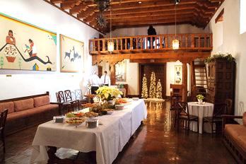  Dobkin Boardroom | 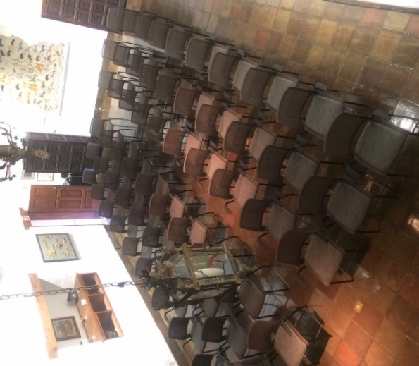  Dobkin Boardroom – Theatre style with 60 chairs
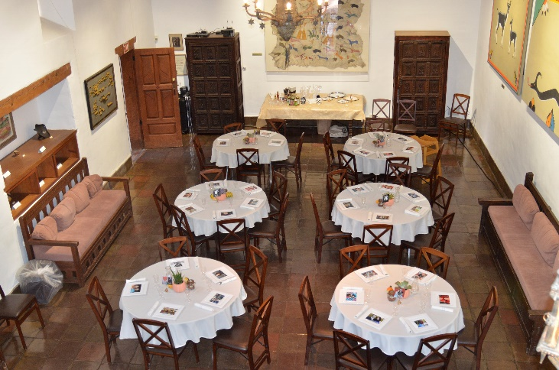  Dobkin Boardroom with six – 48” Rounds  (6 people per table) | 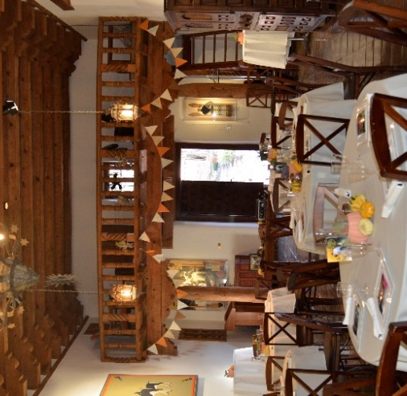  Dobkin Boardroom with six – 48” Rounds  (6 people per table)
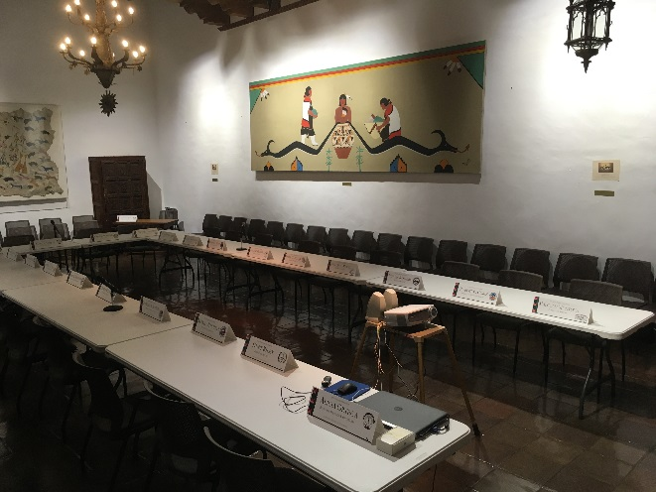  Dobkin Boardroom (U- shape set-up for 21 people) | 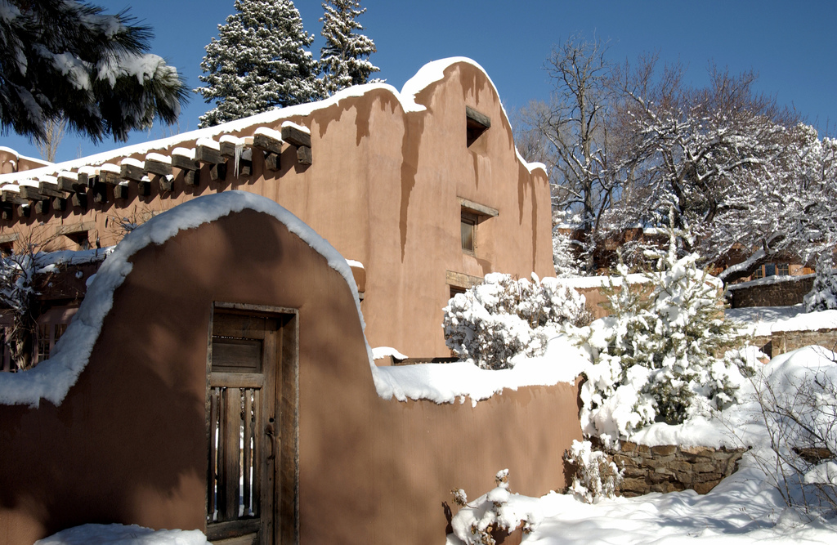  Dobkin Boardroom
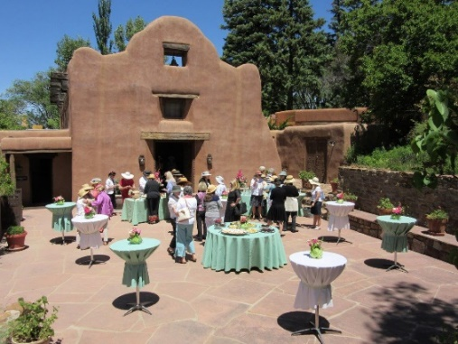  Dobkin Boardroom Patio (facing West) | 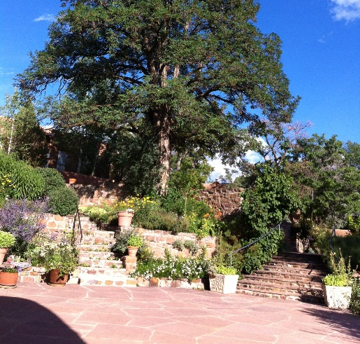  Dobkin Boardroom Patio (facing East)
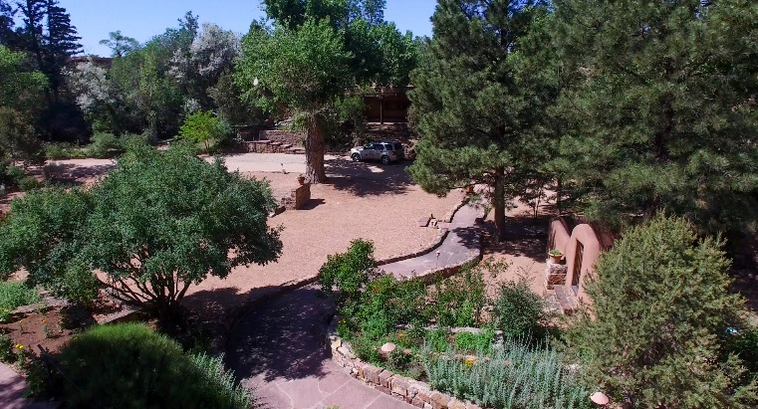  Cottonwood Patio (Facing South East) | 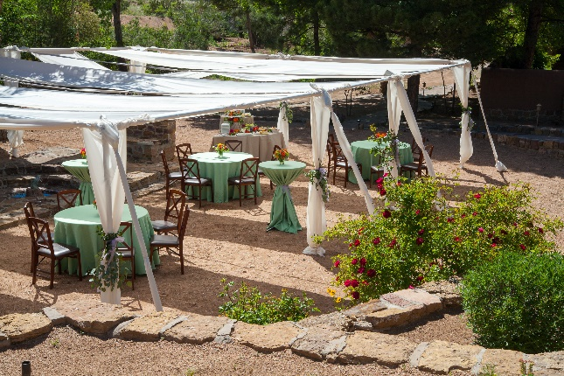  Cottonwood Patio (detail)
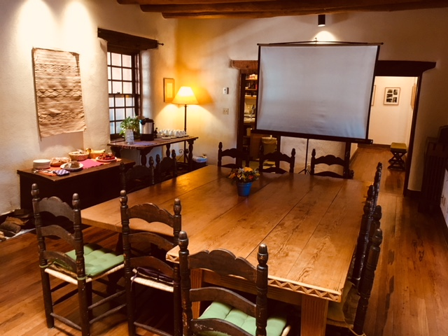  Schwartz Seminar House Dining Room (set-up for 12 people) | 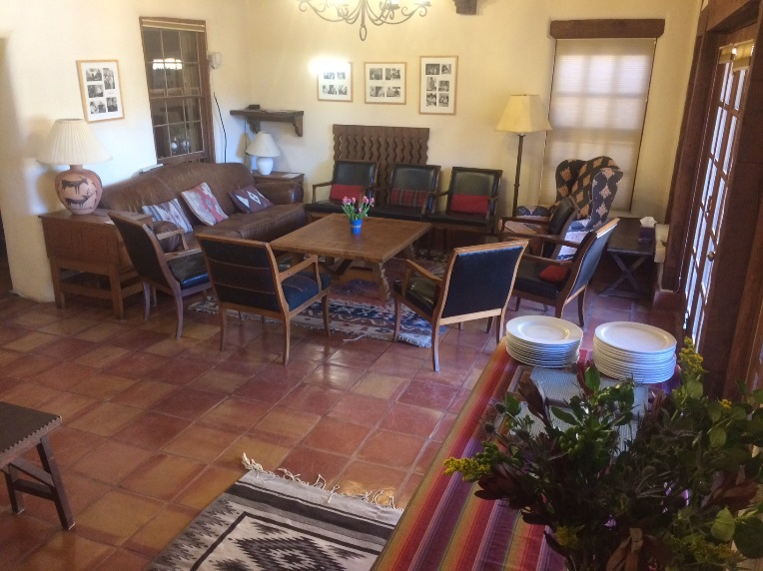  Schwartz Seminar House Living Room

